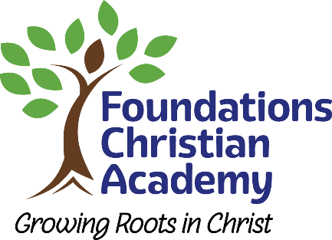
FOUNDATIONS CHRISTIAN ACADEMY
377 Upper Snake Spring Road, Everett, PA 15537
Phone: 814-623-2840 Fax: 814-623-4864
www.fcagrowingroots.com
Home of the Eagles
“Those who are planted in the house of the Lord shall flourish in the courts of our God.” Psalms 92:13

Christian Athletics
Christian athletics is a ministry. When athletics are seen from the Christian perspective, winning has a broader definition and our athletes a greater purpose. We want our coaches and athletes to be used of God in the lives of those they meet. FCA athletics always aim to be sensitive to the leading of the Holy Spirit as our Lord opens doors for active ministry.
Christian athletics is an arena for teaching the principles of God’s Word. Athletics is an opportunity to practice God’s principles. Examples of these principles are controlling the feelings that arise in competition, working together as members of the body of Christ, winning from God’s perspective rather than a person’s, being submissive to authority, and demonstrating the fruit of the Spirit during stressful situations. It’s our hope that our athletes are controlled by the Holy Spirit and produce Christ-like actions so that others may see Jesus through them.

Athletic Standards
The Christian athlete should exhibit an intense desire to improve without having to be forced.
The Christian athlete must be fully committed to this ministry, games and practice.
During the heat of competition, the Christian athlete must maintain self-control. During this time many people watch to see if Christ has made a difference in the Christian athlete….Instead, be filled with (controlled by) the Spirit.
The Christian athlete should do nothing to discredit self, their family, team or school during or apart from an athletic event.
The Christian athlete always shows respect to ALL at ALL times.

Athletic Code of Conduct

The athlete’s conduct is always a credit to the Lord and to the school, on the athletic field and in the community.
The athlete recognizes and abides by the coach’s particular rules and procedures as approved by the Athletic Director. Parents receive these rules and guidelines prior to the beginning of each sport season.
The athlete abides by the authority of the coach at all times.
The athlete shows respect to all those in authority.
The athlete obeys all rules set by the school and complies with the spirit and letter of the rules, year round, including summer break.
The athlete does not use alcohol, drugs, or tobacco or attend parties where these are present. The athlete cares for the equipment (uniform included) issued and complies with all instructions that may accompany it. Such equipment is worn only on the athletic field/court, not to school or in the community unless the Athletic Director gives special permission. Lost or misused equipment is replaced at the player’s expense. At the end of the season the athlete turns in all equipment on the date requested. If after seven (7) days, the equipment is not returned, the athlete is billed for the equipment, unless otherwise approved by the Athletic Director.
The athlete does not participate or practice in any athletic event on the day absent from school for more than half a day, unless approved by school administration.
The athlete is aware of and maintains academic eligibility.

Athletic Fees
Cost
$100.00 for FCA athletic fee.
**Note: Jr. High Co-op will carry additional fees of $50.00 for PIAA Co-op fees.
Due Date
Fee is due two weeks prior to 1st scheduled Practice. Fee is to be paid in the school office.
Checks should be made payable to FCA Athletic Department.

Signature of Christian Athlete

_________________________________________________________ Date________________

Signature of Parent/Gardian

__________________________________________________________ Date________________

